**5.**Scenario: You are a data analyst working for a car manufacturing company. As part of your analysis, you have a dataset containing information about the fuel efficiency of different car models. The dataset is stored in a NumPy array named fuel_efficiency, where each element represents the fuel efficiency (in miles per gallon) of a specific car model. Your task is to calculate the average fuel efficiency and determine the percentage improvement in fuel efficiency between two car models.

Question: How would you use NumPy arrays and arithmetic operations to calculate the average fuel efficiency and determine the percentage improvement in fuel efficiency between two car models?

**Code:**

import pandas as pd

import numpy as np

df = pd.read_csv(r"C:\Users\jampa\OneDrive\文档\fuel_efficiency_data.csv")

fuel_efficiency = df['FuelEfficiency'].to_numpy()

average_efficiency = np.mean(fuel_efficiency)

efficiency_model_2 = df.loc[df['CarModel'] == 'Model_2', 'FuelEfficiency'].values[0]

efficiency_model_7 = df.loc[df['CarModel'] == 'Model_7', 'FuelEfficiency'].values[0]

percentage_improvement = ((efficiency_model_7 - efficiency_model_2) / efficiency_model_2) * 100

print(f"Average Fuel Efficiency: {average_efficiency:.2f} mpg")

print(f"Fuel Efficiency of Model_2: {efficiency_model_2:.2f} mpg")

print(f"Fuel Efficiency of Model_7: {efficiency_model_7:.2f} mpg")

print(f"Percentage Improvement from Model_2 to Model_7: {percentage_improvement:.2f}%")

**Output:**

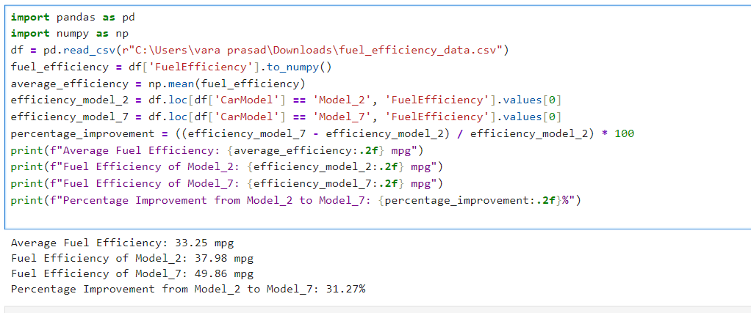

Dataset:

|  |  |  |
| --- | --- | --- |
| CarModel | FuelEfficiency | |
| Model_1 | 48.40069 |
| Model_2 | 37.98048 |
| Model_3 | 49.99469 |
| Model_4 | 18.80269 |
| Model_5 | 24.44225 |
| Model_6 | 39.59364 |
| Model_7 | 49.85823 |
| Model_8 | 22.65388 |
| Model_9 | 15.46178 |
| Model_10 | 25.3592 |